CS 255 System Design Document
Bruno F. Rivera Flores
This template lays out all the different sections that you need to complete for Project Two. Each section has guidance to prompt your thinking. You will need to continually reference the interview transcript as you work to make sure that you are addressing your client’s needs. There is no required length for the final document. Instead the goal is to complete each section based on what your client’s needs are. Remove this note when you are finished, and replace all bracketed text with the relevant information.

UML Diagrams

UML Use Case Diagram
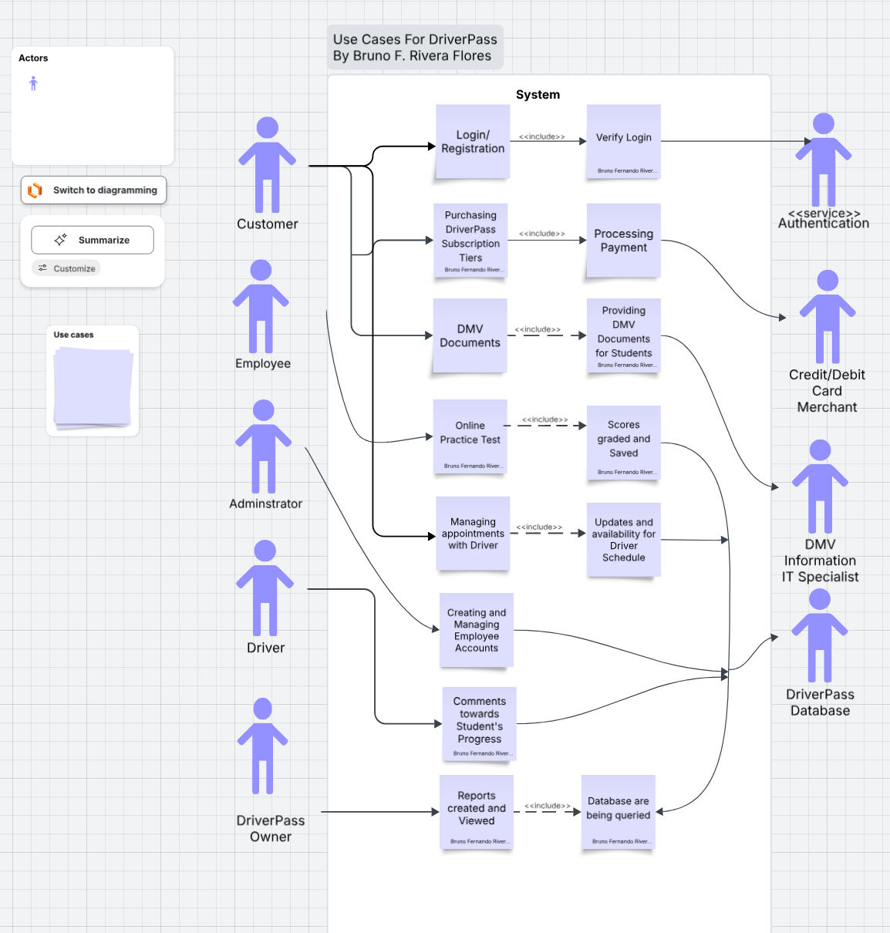

UML Activity Diagrams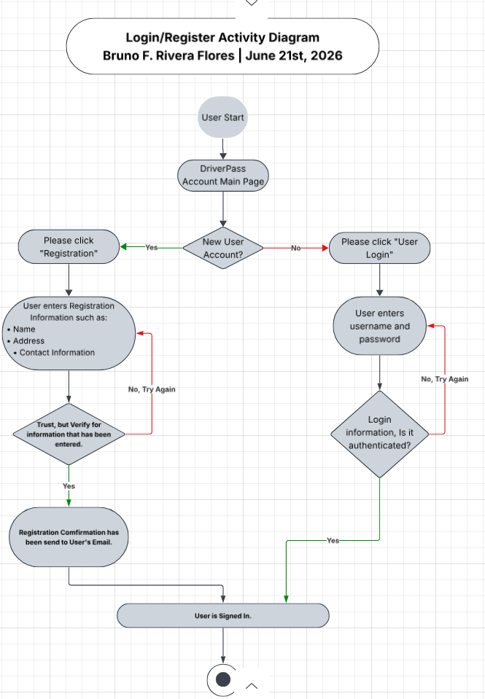
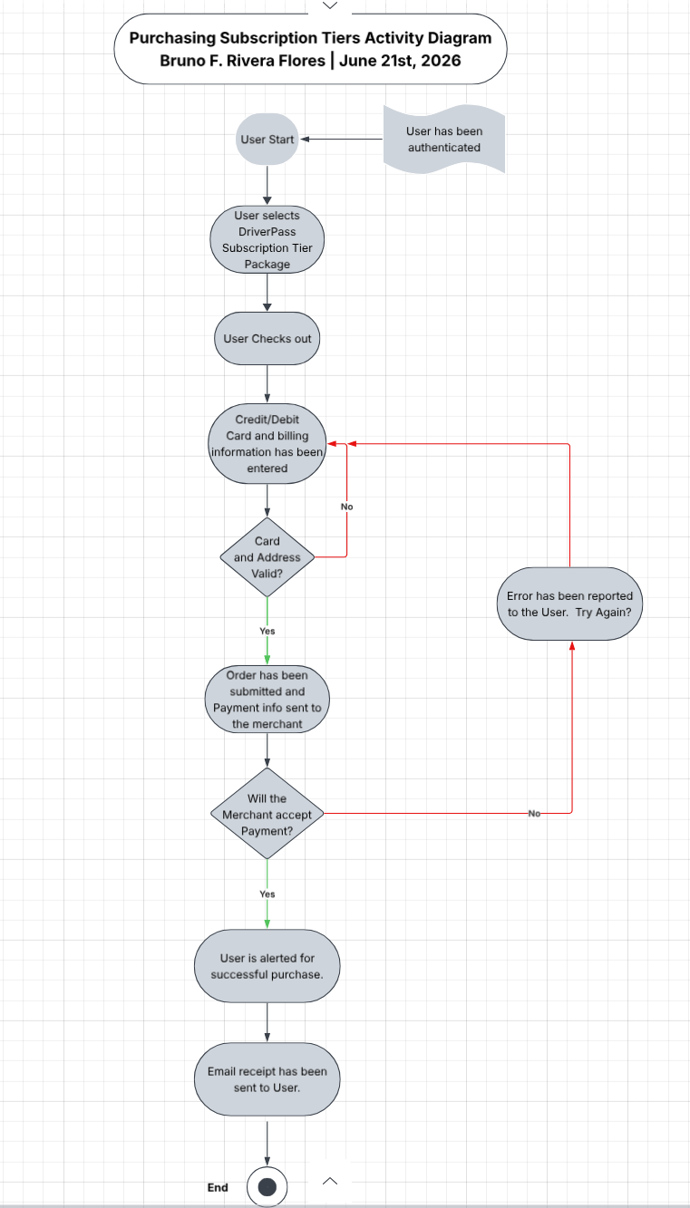

UML Sequence Diagram
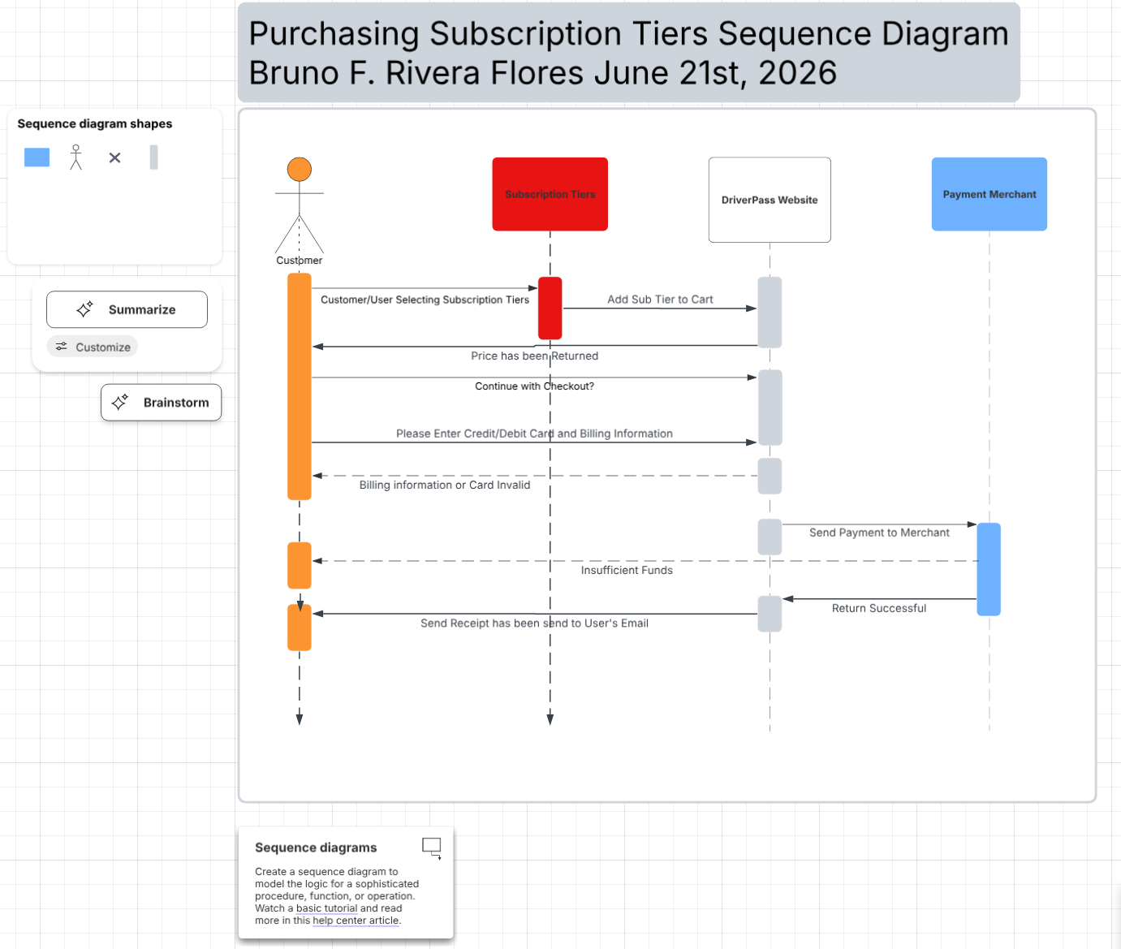

UML Class Diagram
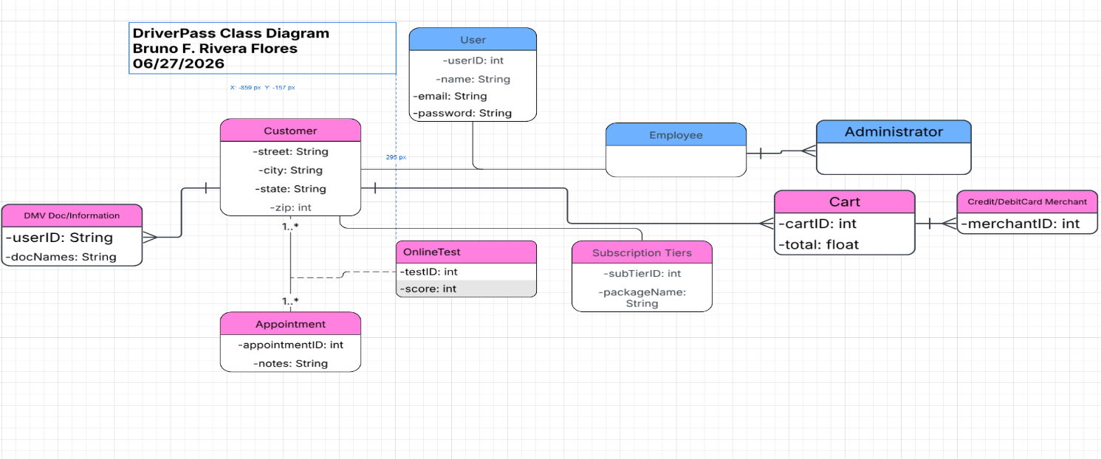

Technical Requirements
The DriverPass website needs to be accessible in the United States of America. The reason for fast, streamlined, robust services must be performed in the states first. Data Centers with the necessary overhead will keep the DriverPass website server and database secure. One server will host the database, while the other server will host the publicly accessible site where users/customers are able to log into the system. To save costs, since it wasn’t discussed in the transcripts surrounding the budget. I would suggest Windows Servers for the most stable release, and a web server application like Apache. Both this and the database application, MySQL does not have any licensing costs linked to these suggestions. As for security, we need a trusted firewall to protect website ports and Security software to preventing malware.

